Progressive Employment – Assessment Practices for Upskilling/Backfilling Individuals Within Career Pathways

  - How can the Progressive Employment model be used as an assessment tool to support career pathways advancement and also meet the needs of business?
Janet Drudik, MS, CRC, Nebraska Vocational Rehabilitation
Kelly Haines, MA, Institute for Community Inclusion, University of Massachusetts Boston

Presentation Abstract:
In this presentation we will describe the PE model as a strategy for conducting vocational evaluation and assessment in a work-based setting. We will discuss how this tool can meet the needs of both jobseekers and business as a dual-customer strategy, and promote advancement along career pathways in high-growth/high-demand industries.
Presentation Link: https://prezi.com/gjjyo1u4hyk5/?token=fca969ad377763b39258c5b74261ba122d11a7fb46a8da73619be1370d046f18&utm_campaign=share&utm_medium=copy

Presentation Narrative:

Introduction
To support individuals in exploring new career clusters or pathways within a targeted industry or sector, Nebraska VR uses the Progressive Employment model. Vocational Rehabilitation programs have typically focused on services and supports often leading to entry-level positions rather than mid-level or high-quality occupations. Nebraska Vocational Rehabilitation’s Career Pathways Advancement Project (CPAP) uses an “upskill/backfill” approach to help individuals with disabilities gain credentials necessary to advance into jobs with better wages and more employer-provided benefits. Many individuals wanting to advance in their careers benefit from work-based learning experiences as a vocational evaluation and assessment tool.

Overview of the Progressive Employment Model

History
The PE model originated in Vermont in 2009 as a way to engage jobseekers with disabilities and significant barriers to employment in low-risk / no-risk work-based learning experiences to build confidence and gain momentum toward employment. In 2012, the Institute for Community Inclusion at the University of Massachusetts Boston received a federal grant from the National Institute on Disability, Independent Living, and Rehabilitation Research to study the emerging model and replicate it in other states, including Nebraska, Maine, and Oregon.

Key Model Components
The Progressive Employment (PE) model is a dual-customer approach designed to meet the needs of both jobseekers and businesses and has demonstrated potential to have a positive impact on employment outcomes for persons with the most significant disabilities and multiple barriers to employment. The PE model uses work-based learning strategies to meet the needs of both the employer and the jobseeker with a disability while minimizing the risks for both parties. Elements of the model include early jobseeker engagement in work environments (everyone is ready for something), a strong team approach, and VR-provided short-term liability insurance.

Figure 1. Progressive Employment Model Components

Adoption in Nebraska
Nebraska VR provided PE services to over 1000 VR customers since 2015, and has fully integrated this model as a complement to traditional vocational evaluation and assessment strategies. Work-based learning experiences include company tours, job shadows, informational interviews, and paid work experiences that occur at a business and are intended to be a low-risk/no-risk way for jobseekers to have an employment experience and business to be exposed to a jobseeker without the requirement for a direct hire.

Progressive employment is:
- A series of work-based learning experiences geared to the skill level of the individual and increasing in skill levels required
- A method to evaluate existing work skills, reduce fear and identify training, support or accommodation needs
- A way to develop interpersonal and customer service skills
- An opportunity for individuals to explore possible careers in short-term placements
- A way to introduce a candidate to a prospective employer, especially for those individuals who struggle to get their foot in the door
- A tool to build a resume and professional references

PE as a Tool in the Meet You Where You Are Approach

Nebraska VR clients are introduced to the Meet You Were You Are Model (MYWYA) during the initial interview. The services of rapid engagement, discovery phase, employment services and placement are available as part of MYWYA. The rapid engagement service is an approach allowing clients to explore their interest and skills in a competitive work setting. The discovery phase is useful for individuals who are struggling to identify a career pathway and may not be ready to participate in a worksite experience. During the discovery phase individuals may complete pencil/paper assessments and exploration in a vocational evaluation facility prior to a rapid engagement activity. The rapid engagement and discovery phase services are not exclusive to each other and may occur simultaneously.

PE as a Tool for Vocational Evaluation and Career Assessment for Jobseekers

PE can be a strategy for conducting vocational evaluation and assessment in a work-based setting.
- It is an assessment service, however can be completed prior to or after IPE development if wanting to assess a client’s skills, interest, abilities, etc.
- Provides clients the opportunity to engage with a business to help them explore an occupation or practice a mock interview by talking with a business owner or someone who works at the company. It promotes the VR mission that both clients and employers are our customers.
- A “soft touch” approach for VR Specialist and clients to begin working with companies they have an interest and businesses who may not be willing to work with VR or individuals with disabilities in the past.
- When a client in placement status struggles to obtain employment, an assessment such as OJE or a mock interview with an employer may be beneficial to determine the client’s skills, but also so the employer can see the client’s potential for employment.

PE for Career Advancement for Jobseekers

The question is often asked of clients, “what kind of job do you want?” The question should be, “what is the type of career field or pathway do you want to work within?” When providing career exploration with clients, it is important to help them understand the concept of the career pathway model. The model below identifies the six career fields in the center to assist individuals in identifying a major interest category. As clients begin exploring a career field they begin to specify a career cluster, a career pathway and eventually a career specialty. Identifying a career pathway early in an individual’s work career allows for gaining additional work skills within a pathway, better opportunities for advancement and increased earnings for economic self-sufficiency.
The progressive employment model has proven to be effective for individuals wanting to choose their career pathway interest. Progressive employment allows for opportunities to assist individuals to obtain their first position or advancing within that same pathway. The goal is to gain knowledge of a career cluster/pathway through worksite opportunities like job shadowing, informational interviews, tours, and on-the-job evaluations/trainings. Using a work-based learning experience provides the opportunity to try it out, dispel myths and gain additional knowledge to pursue a specific career pathway.

Figure 2. Nebraska Career and Technical Education Model
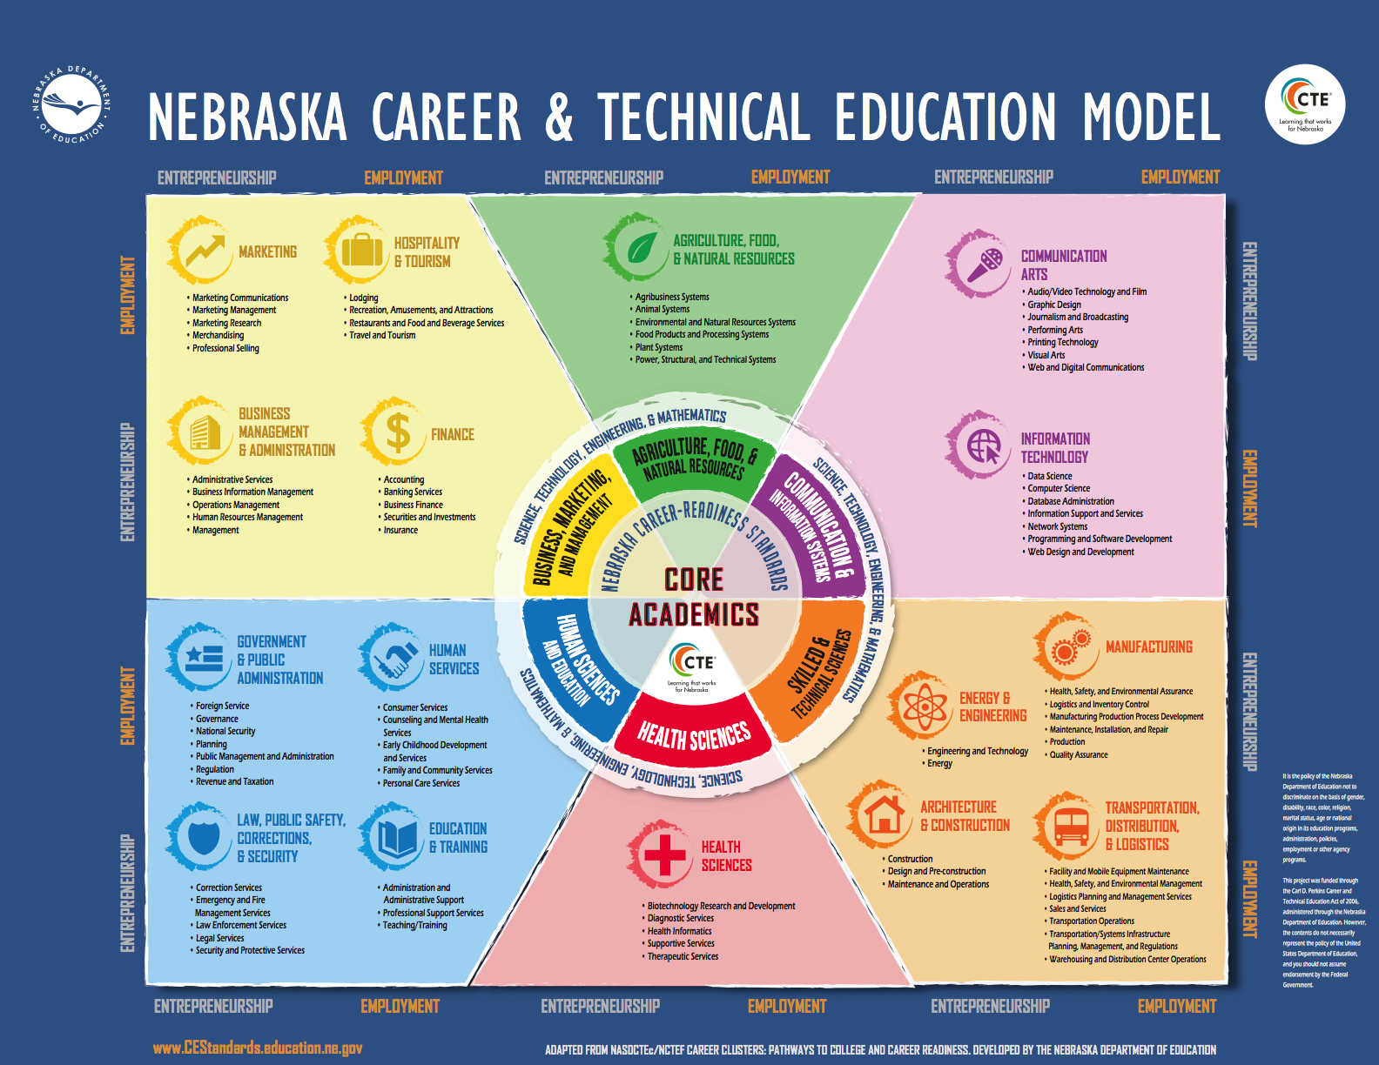

Figure 3. Nebraska Career Education Model Career Cluster: Manufacturing

PE for Meeting the Needs of Businesses

- The PE Model includes several components designed to meet the needs of businesses. Staffing includes Business Account Managers who do not carry a caseload; Communication strategies: e.g. Working in Nebraska (WIN) Meetings; Employer Database; Costs of compensating jobseekers covered by VR (no cost to business); Worker’s compensation and liability coverage for work-based learning experiences.
- Evaluation / Assessment: Dual-customer – how PE meets needs of jobseekers and also as an evaluation tool for businesses (means of business engagement and employer supports; assess a work environment, organizational culture, accommodation needs
- Career advancement: upskilling incumbent workers and backfilling entry level positions in high-demand / high-growth industries

Research Findings to Date

- Including Vermont, over 4,300 individuals have received PE to date across the country.
- Over 500 individuals in the three replication states have closed into competitive integrated employment

Preliminary outcomes in Nebraska are promising:

Nebraska VR | Adult (N) |  | Youth (N)
Case Status | PE | Non-PE | PE | Non-PE
Open case | 262 | 2277 | 147 | 983
Successful outcome | 193 | 2408 | 59 | 292
Terminated Unsuccessful | 235 | 3823 | 111 | 1161
Total | 690 | 8508 | 317 | 2436
Successful Closure Rate* | 45.09% | 38.65% | 34.71% | 20.10%

*Successful closure rate = # Successful outcome/ (# Successful outcome+ #Terminated Unsuccessful including prior to IPE). Not convention for reporting successful rehabilitation to RSA as pre-IPE closures are included in analysis.

Overall:
- PE can be extracted from VT and successfully replicated in other state VR agencies
- Preliminary outcomes are promising
- Interest in the field (in EBP, dual-customer approaches) continues to grow
Nebraska Career Pathways Advancement Project evaluation findings to date
Table 1. Wage Summary of CPAP Clients Closed in Competitive Integrated Employment Since Grant Inception
Overall (N=59) | Wages at CPAP Application | Wages at CPAP Closure | Wage Change  (App --> Closure)
Median | $520.00 | $780.00 | $290.00
Mean (Average) | $485.52 | $858.90 | $372.48
Minimum | $0.00 | $384.00 | $0.00
Maximum | $1,000.00 | $1,399.80 | $1,346.00

Table 2. Total Number of Benefits and Benefits Change Overall Since Grant Inception
Overall N=59 | Benefits at CPAP Application | Benefits at CPAP Closure | Benefits Change App-->Closure
Median | 1.00 | 4.00 | 2.00
Mean (Average) | 1.56 | 3.76 | 2.20
Mode | 0.00 | 4.00 | 4.00
Minimum | 0.00 | 0.00 | -1.00
Maximum | 5.00 | 5.00 | 5.00

Conclusions
PE can be a strategy for conducting vocational evaluation and assessment in a work-based setting. This tool has proven to be especially effective for individuals seeking to advance along a career pathway.
The future of work for people with disabilities must consider career pathways and advancement toward greater economic self-sufficiency, as measured by earned wages and also employer-provided benefits (e.g. paid time off, health insurance, and retirement benefits). We cannot wait to close the employment gap between people with and without disabilities before we consider advancement, and the PE model has shown great promise as a tool for jobseekers and incumbent workers with disabilities and barriers to employment.

